This is a test document, to evaluate the functionality of the .doc file format, from a web server.
Hyperlinked test: A list of websites www.David100.com

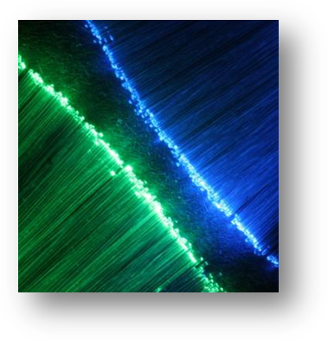
The above is a photograph of tiny fiber optics, which is part of a novelty ballpoint pen. It contained its own light source, and it had the ability to change colors. This is magnified about 50 times.

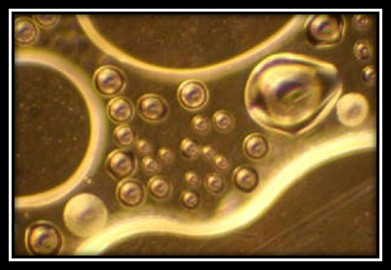
This is a microscopic object, which spontaneously formed, when a speck of sulfur was heated between a glass slide and a cover glass. This photograph was taken with reflected light, using a long time exposure, with a magnification of approximately 100 times.

