Techniques for Documenting with Proof or Supporting Evidence, and Related Strategies for Problem Solving
By David Alderoty © 2016

Chapter 5) Technique 5, Using Rules, Laws, and Court Decisions, for Information, and for Evidence to Support the Statements in Your Document

This e-book presents 28 techniques for supporting the validity of the statements and documents you write.
Left click on the above for a list of the techniques

This chapter contains a little over 2,260 words

If you want to go to chapter 4, left click on the following link:

www.TechForText.com/DP/chapter-4

To contact the author use David@TechForText.com
or left click for a website communication form

Table of Contents, and an Outline of this Chapter
The following is a hyperlink table of contents, as well as an outline of this chapter. If you left click on a blue underlined heading, the corresponding topic or subtopic will appear on your computer screen. Alternatively, you can scroll down to access the material listed in the table of contents, because this chapter is on one long webpage.

Topic 1.) Technique 5, Using Rules, Laws, and Court Decisions as Supporting Evidence 3
Subtopic, Definitions to prevent confusion 5
Subtopic, Dividing Laws into three Categories 5
Topic 2.) The Difference Between Technique 5, and the other Techniques in this E-Book, in Regard to Universality and Validity 7
Subtopic, Rules and Laws Are Not Universally True, but Concepts that Relate to most of the other 28 Techniques are Universally True 8
Subtopic, Two Common Factors of Rules and Laws 10
Topic 3.) Special Controls in Google Scholar for Finding the Law, and Web-Based Articles and Videos 12
Web-Based Articles for Additional and Supporting Information, for Technique-5 15
Web-Based Videos for Additional and Supporting Information, for Technique-5 16

This E-Book Provides Additional and Supporting Information from other Authors, with Web Links

This e-book contains links to web-based articles and videos from other authors, for additional, alternative, and supporting information. The links are the blue underlined words, presented throughout this e-book. However, some of these links are to access different sections of this e-book, or material on my own websites.
Quotes and paraphrases in this e-book have hyperlinks to access the original source. The quotes are presented in brown text, which is the same color of these words. (The precise text color is RGB Decimal 165, 42, 42, or Hex #a52a2a)
Some of the web links in this e-book will probably fail eventually, because websites may be removed from the web, or placed on a new URL. If a link fails, use the blue underlined words as a search phrase, with www.Google.com If the link is for a video, use www.google.com/videohp The search will usually bring up the original website, or one or more good alternatives.

For those who prefer listening, as an alternative to reading, this book is recorded in an audio format.

For an audio narration of this chapter, left click on these words (requires 16 minutes, and 55 seconds).

Topic 1.) Technique 5, Using Rules, Laws, and Court Decisions as Supporting Evidence
|||
Technique-5 involves using rules, laws, and court decisions to support the validity of the statements in your document. If the primary focus of the document you are writing is law, and/or court decisions, technique-5 can serve a dual function. Specifically, when you find the information you need, you also obtained the supporting evidence by stating the source, using, an appropriate citation style. For law school studies, or for formal legal documents, access the following free e-book: Introduction to BASIC LEGAL CITATION © 2015 by Peter W. Martin
Technique-5, can involve citations consisting of quotes, paraphrases, or a referral to a specific source of information that supports the statements and arguments in your document. The sources used with this technique are obviously rulebooks, law books, court decisions, and any legal document. It can also involve testimony from a court case, sworn affidavits, contracts, information obtained from criminal investigators, and forensic laboratories.

Subtopic, the Basic Utility of Technique-5
|||
Technique-5 can be used for writing an academic paper, similar to a conventional school assignment, or research paper. However, technique-5 is often used to support legal arguments, claims, and legal rights. At the simplest level, this can involve an individual writing an informal document asserting a claim or his or her legal rights. If documents of this nature do not resolve the issue, then a lawyer can be hired, or complaint may be issued to a state or federal agency. This would generally result in formal documents written by lawyers or government officials. These documents would have a set of legal arguments, which would be supported by citations involving relevant laws.

Subtopic, Definitions to prevent confusion
|||
The term law used in this chapter refers to the laws created by government and its legislative bodies. It should not be confused with the terminology used in other disciplines, such as in science or nature. A good example is Newton’s law of motion.
In this chapter, the term rule refers to regulations that are not formal laws, and they only apply to a specific club, organization, business, game, and/or activity. Rules are similar to laws, except they are generally not enforced by governments, police officers, and the penalties for violating them is usually minor. Penalties can include temporary or permanent exclusion from a club, organization, business, or game.
There are formal rules that are usually written in formal documents, and there are informal rules that are not documented. Sometimes informal rules contradict formal rules, and vice versa.

Subtopic, Dividing Laws into three Categories
|||
I am dividing laws into three broad categories, for this e-book. The first category is comprised of laws that have an obvious moral basis, such as to protect life and property. Some examples are laws against stealing, assault, and murder. Laws in this category can be found in most societies.
The second category, are comprised of laws against behaviors that risk life, property, or the well-being of society. Usually, these laws have a moral basis, which in some cases may not be apparent. When these laws are violated, in a specific situation there might not be any apparent adverse outcomes. However, there is usually a risk of one or more of the following: accidents, physical or psychological illness, loss of life, damage to property, adverse moral influence, or other undesirable outcomes. Some examples are drunk driving, driving a car above the speed limit, practicing medicine without a license, carrying concealed weapons. Specific laws in this category are often unique to a specific nation, or locality. For example, carrying a concealed weapon is legal in a number of states in the US, but in some states, it is considered a serious crime.
The third category are legal requirements and orders that require an individual or corporation to carry out specific actions, such as disposing of garbage in a specified way, showing up for jury duty, and paying taxes. Laws in this category vary greatly from one nation or locality to another.

Topic 2.) The Difference Between Technique 5, and the other Techniques in this E-Book, in Regard to Universality and Validity
|||
Technique-5 is unique when compared to most of the other 28 techniques discussed in this e-book. With most of the techniques, the truth-value can be tested experimentally, and it is ultimately determined by nature and/or logic. A simple example is X=50, if X+5=55. The validity of this statement can easily be confirmed by three of the techniques explained in this e-book, which are deductive reasoning, mathematical calculations, or by experimentation.
The above is not the case with technique-5. That is The truth-value of rules or legal statements cannot be confirmed experimentally, and it is not determined by nature or logic. The truth value of rules and legal statements are determined by people, which can involve one or more of the following:

- By convention: This involves previous court decisions, (especially of higher-ranking courts) influencing subsequent court decisions. This can also involve traditionally accepted values, and conventional rules of fairness for doing business.

- By government, including legislative bodies, mayors, governors, presidents, prime ministers, Kings, Queens, dictators, and individuals who are in a power position

- The voters, in a city, state or nation

- Creating rules for a business: This includes individual entrepreneurs, CEOs, managers, stockholders, who are creating rules to govern their employees and customers.

- In religion, by religious leaders, traditions that relate to the religion, scrolls, and other religious documents

- The military and police: This can involve internal rules to govern military personnel and the police force, as well as formal or informal rules for the general public. This is probably more prevalent in nondemocratic societies.

- People who can influence directly or indirectly one or more of the following: government leaders, officials of a governing body, business leaders, business owners, stockholders, and voters: People in this category are not creating the law. However, they are influencing or persuading officials, and/or voters concerning the selection of specific laws, and/or the creation of laws.

Subtopic, Rules and Laws Are Not Universally True, but Concepts that Relate to most of the other 28 Techniques are Universally True
|||
Another important difference between technique-5 and most of the other techniques presented in this e-book is universality. For example, the truth-value of this statement: X=10, if X+90=100 can be determined to be true or false, in all localities of the universe, with deductive reasoning, basic mathematical calculations, or experimentation. (Note: The phrase all localities of the universe, is somewhat theoretical. On a simplified and practical level, it should be thought of as all known localities.)
Note, when dealing with complex examples, the universality is based on environments with similar physical, electrical, chemical, and biological properties. For example the statement: water is a stable liquid is universally true, but only in environments with standard ambient conditions. If you put water on the surface of the sun, it is a very unstable liquid, and it will quickly decompose into hydrogen and oxygen.
The important point here is the concept of universality, as described in the previous two paragraphs, does not apply to technique-5. Specifically, a rule or legal statement that is true in one locality, may be false and another. For example, the following statement is true in some sections of the United States, but it is also false in a number of US cities and states.
It is legal to carry a concealed gun without a permit This statement is true in Alaska, Arizona, Idaho, Kansas, Maine, Vermont. However, it is false in California, Connecticut, Delaware, Hawaii, Maryland, Massachusetts, New Jersey, New York, and Rhode Island.

Subtopic, Two Common Factors of Rules and Laws
|||
There are two common factors involved with most rules and laws. Factor 1 is the threat of punishment if they are disobeyed. Factor 2 is an understanding of the rule or law by the people that are governed by it, especially in terms of its utility and/or its morality. If when a rule or law is deficient in factor 1 or 2, it might be disobeyed by many individuals within the governed locality. However, if either one of the factors is very strong it most likely will be obeyed. Specifically, if the chance of severe punishment for violating a law were very great, most people would probably obey it, even if they disagreed with it. Similarly, if most people understanding a law, especially in terms of its utility, and/or morality, they will probably obey it, even if the penalties violating it are minimal or nonexistent.
Sometimes specific rules or laws are not enforced. This can happen for a number of reasons, such as the following:

- The rule or law is believed to be irrelevant or irrational by most people: This can happen, when a law is very old, or when it was created for social and/or environmental conditions that no longer exist.

- When a law is thought to be unenforceable, or when the morality that the law was based on as changed.

When a rule or law is not enforced, or abolished, one of the following may happen:

- The law or rule may be ignored or disobeyed by some, or even most people

- People might violate the rule or law without knowing that it even exists

- In some cases, a law might be obeyed because of tradition, or moral, religious, or practical reasons, even if there is no legal penalty involved. This can also happen even when a law is abolished by court decisions, or legislation. A good example is a law in New York State that prohibited women from going topless. This law was abolished by court decision July 7, 1992, but even when the temperature reaches the 90s in New York, women generally do not go topless. On very rare occasions, a female street performer, or women involved in a protest might expose their breasts. See THE PEOPLE &C., RESPONDENT, v. RAMONA SANTORELLI AND MARY LOU SCHLOSS, APPELLANTS, ET AL., DEFENDANTS.

Topic 3.) Special Controls in Google Scholar for Finding the Law, and Web-Based Articles and Videos
|||
Google search (www.Google.com) and Google video (www.google.com/videohp ) are good search engines for finding legal material that is suitable for laypeople, and for finding videos of court cases. However, if you need legal information for graduate studies, a law school assignment, or for litigation, you should use Google scholar. Google scholar has an elaborate set of controls for finding the law, including court decisions. How to use these controls is explained below in four steps.

Step 1.) Left click on the following URL http://scholar.google.com When google scholar opens, it will look like the following:
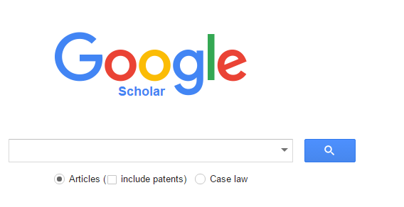

Step 2.) Click on Case law, on the right, and you will see the following:
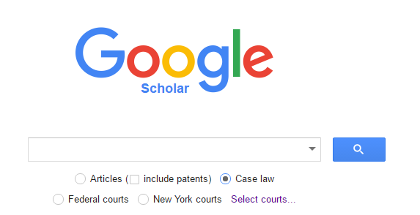

Step 3.) Examine the above image, and you will see the following choices:
- include patents
- Case law
- Federal courts
- New York courts
- Select courts…

Click on the items that relate to your search. If you want a court that is not displayed, click on the words Select courts… and you will see a list with all the state and federal courts, as shown below:

Note, the following is only a section of the list presented for illustration purposes. If you want to see the actual list left click on these words.
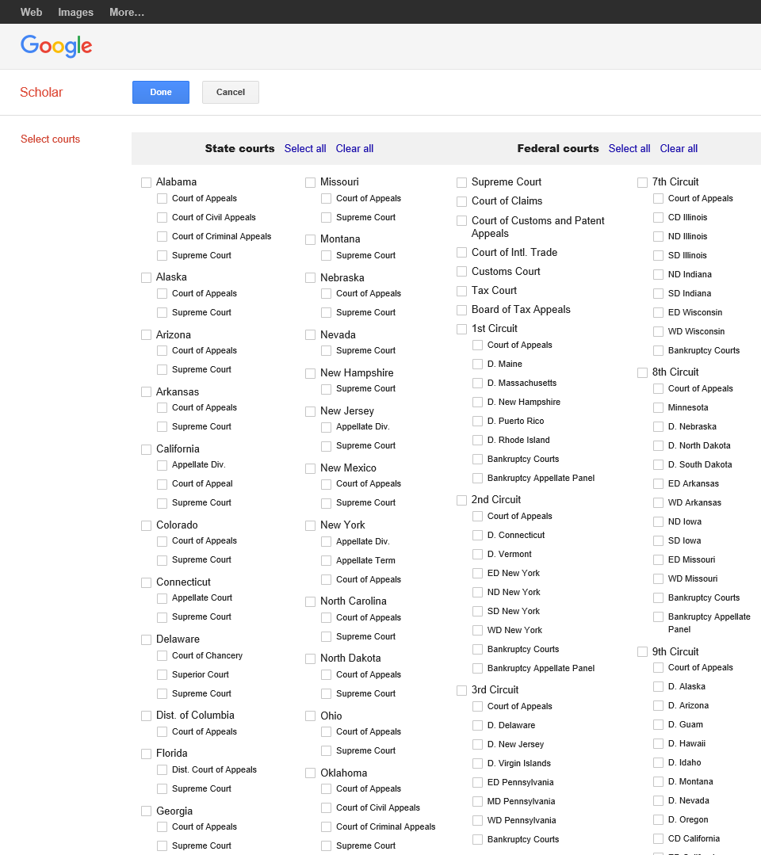
Step 4.) Check one or more courts on the list that relates to your search goals. You can even select all of the state courts, all of the federal courts, or all of the state and federal courts. To select all of the state courts click on the blue words on upper left of Google’s webpage: State courts Select all To select all of the federal courts click on the blue words on the upper right of Google’s webpage: Federal courts Select all

If you want to eliminate all of the above steps, you can go directly to the list of courts, by left clicking on the following link:
Select State or Federal Courts

Web-Based Articles for Additional and Supporting Information, for Technique-5
|||
Using Google Scholar to Find Law Review Articles, Kasia Solon

U.S. Federal Case Law, Bill Turner

U.S. Federal Courts of Appeals Case Law

Law Student’s Quick Guide to Legal Citation, Steve Donwebe

Researching The Law, Where You Can Go And What You Can Find

Bluebook, a Uniform System of Citation, Harvard Law Review

Laws and Legal Research

Legal citations and abbreviations

HOW TO WRITE A LEGAL ARGUMENT by M. R. Franks

WRITING THE LEGAL ARGUMENT: A FEW WRITING SAMPLES

FindLaw is a useful resource for finding legal information, and its URL is
www.findlaw.com

Learn About The Law

The Law for the layman

Basic principles of law Bill Turner

HOW TO WRITE AN AFFIDAVIT

Understand your legal issue, solve your legal problem

Supreme Court Research Guide

Introduction to Basic Legal Citation (online ed. 2016) By Peter W. Martin

FindLaw is a very good resource, and its URL is http://statelaws.findlaw.com

Introduction to Basic Legal Citation: e-book versions and "Citing ... in brief" videos
(fall 2016)

U.S. Federal Case Law

Web-Based Videos for Additional and Supporting Information, for Technique-5
|||
Part 1 of Law Class for Laymans 101, Tom Collins

lawclass101 part2, Tom Collins

lawclass101 part3 Tom Collins

lawclass101 part4 Tom Collins

Legal System Basics: Crash Course Government and Politics #18

How to Understand the American Judicial System

United States Government The Judicial Branch

Basic principles of law Bill Turner

If you want to go to chapter 6 of this e-book, left click on the following link:

www.TechForText.com/DP/chapter-6

