Techniques for Documenting with Proof or Supporting Evidence, and Related Strategies for Problem Solving
By David Alderoty © 2017

Chapter 25) Techniques 24, 25, 26, 27, and 28

In this chapter the following techniques are covered:

- Technique 24) Observations as supporting evidence

- Technique 25) Electronically and/or photographically recorded evidence

- Technique 26 ) Using URLs, and/or hyperlinks to display supporting evidence from the Internet, or other database

- Technique 27) Using your own web-based material as supporting evidence

- Technique 28) This represents any technique that was not covered in the 27 techniques presented in this e-book

This e-book presents 28 techniques for supporting the validity of the statements you write.
Left click on the above for a list of the techniques

If you want to go to chapter 24, left click on the following link:

www.TechForText.com/DP/chapter-24

To contact the author use David@TechForText.com
or left click for a website communication form

Table of Contents, and an Outline of this Chapter
The following is a hyperlink table of contents, as well as an outline of this chapter. If you left click on a blue underlined heading, the corresponding topic or subtopic will appear on your computer screen. Alternatively, you can scroll down to access the material listed in the table of contents, because this chapter is on one long webpage.

Topic 1.) Technique 24) Observations as Supporting Evidence 5
Subtopic, Why Observation Should Be Supported By Additional Evidence 5
Subtopic, When are Observations Good Supporting Evidence 6
Subtopic Observations as Supporting Evidence In Personal Essays, Articles, and Research Papers 6
Additional Information from Web-Based Sources 7
Topic 2.) Technique-25, Electronically, and Photographically, Recorded Evidence 7
Subtopic, Technique-25, for Supporting Statements And Claims that Involve Your knowledge, Skills, and Abilities 9
Topic 3.) Technique-26, Using URLs, and/or Hyperlinks to Display Supporting Evidence from the Internet, or other Database 10
Subtopic, Three Types of Links: URLs, Hyperlinks, And a Combination Of URLs and Hyperlinks 10
How Do You Create a Hyperlink, and a Combination of a Hyperlink and URL 12
For Additional Details About Hyperlinks See the Following Web-Based Material 13
When Not to Use Hyperlinks 14
Avoid Long URLs, by Using a URL Shortener 15
Topic 4.) Technique 27) Using Your Own Web-Based Material as Supporting Evidence 15
Creating Your Own Websites, and Other Alternatives 16
Topic 5.) Technique 28) This Represents Any Technique That Is Not Mentioned In This E-Book 17

This E-Book Provides Additional and Supporting Information from other Authors, with Web Links

This e-book contains links to web-based articles and videos from other authors, for additional, alternative, and supporting information. The links are the blue underlined words, presented throughout this e-book. However, some of these links are to access different sections of this e-book, or material on my own websites.
Quotes and paraphrases in this e-book have hyperlinks to access the original source. The quotes are presented in brown text, which is the same color of these words. (The precise text color is RGB Decimal 165, 42, 42, or Hex #a52a2a)
Some of the web links in this e-book will probably fail eventually, because websites may be removed from the web, or placed on a new URL. If a link fails, use the blue underlined words as a search phrase, with www.Google.com If the link is for a video, use www.google.com/videohp The search will usually bring up the original website, or one or more good alternatives.

For those who prefer listening, as an alternative to reading, this book is recorded in an audio format.

For an audio narration of topic 1, (technique 24) left click on these words (requires 3 minutes, and 52 seconds)

For an audio narration of topic 2, (technique 25) left click on these words (requires 3 minutes, and 38 seconds).

For an audio narration of topic 3, (technique 26) left click on these words (requires 6 minutes, and 18 seconds).

For an audio narration of topics 4 and 5 (technique 27 and 28) left click on these words (requires 2 minutes, and 46 seconds).

Topic 1.) Technique 24) Observations as Supporting Evidence
|||
Technique 24) your own observations, or the observations of others, can be used as supporting evidence for the statements you write. Ideally, observations should be supported by additional evidence, such as photographs, videos, experimentation, multiple observers, etc. Additional supporting evidence is especially important if you are making an unusual claim or argument based on your observations or the observations of others.

Subtopic, Why Observation Should Be Supported By Additional Evidence
|||
If you search historical records, you can find many individuals that claim to have observed phenomena that would contradict science and common sense. Observations and related interpretations and claims, sometimes appear to be influenced by human imagination, more than by reality. People often confuse observations with interpretations. A common example is seeing an object in the sky, and assuming it was created by aliens from another planet. A realistic assumption would be that it was created by people from our planet, who have a history of creating flying objects over the last 2000 years. This includes kites, balloons, gliders, airplanes, jet planes, rockets, and drones.

Subtopic, When are Observations Good Supporting Evidence
|If the observations can be easily confirmed by others, you have good supporting evidence. For an example, let us assume you discover a cave on the side of a mountain. If you provide the exact location of the cave, so others can examine it, your observation is excellent supporting evidence. You would also have good supporting evidence if you provided video or series of photographs of the cave, the mountain, and surrounding area. If you were a well-known explorer, with an established reputation, a detailed description of the cave would probably be considered good supporting evidence, by most readers. If your observations were based on a well-known tourist site, such as Howe Caverns, you would have excellent supporting evidence.
If your observations were based on experimental results, you would have good supporting evidence, if you described the experiment so other people can duplicate it. If other qualified people, could not duplicate your experiment, your observations would be poor supporting evidence.

Subtopic Observations as Supporting Evidence In Personal Essays, Articles, and Research Papers
|||
If you are writing a personal essay, and you describe your observations in a reasonable and believable way, most readers would probably consider it as adequate supporting evidence. However, if your observations were very unusual, or you were writing a scientific article, or research paper, your observations would probably be assessed as inadequate.
For scientific articles and research papers, observation should be supported by additional evidence. If this cannot be done, a simple strategy is not to mention the observations. Another alternative is to explain that the observations are unconfirmed, and they must be evaluated with additional studies. This would encourage others to confirm or refute the observations and related claims.

Additional Information from Web-Based Sources
Writing on Experiences, Observations, Traumatic Events, Margot Finke

How do I Write a Reflection? Why reflective writing?

Personal statements - finding a formula, Video

Topic 2.) Technique-25, Electronically, and Photographically, Recorded Evidence
|||

Technique-25, obviously includes the use of photographs, video, and sound recordings. However, it can also involve other technologies that are used to record data in science, engineering, and medicine. This includes seismographs, sonar recordings, x-rays, MRIs, ultrasound images, electroencephalograms, cardiograms, and oscilloscope recordings of various types of electronic pulses.
Technique-25, can involve taking your own photographs, videos, and making your own sound recordings for supporting evidence. However, it can also involve using published sources that provide photographs, videos, or sound recordings to support the statements in your document.
Sometimes specific type of electronically or photographically recorded evidence can become a main topic of a writing project. This can involve historical videos, photographs, obtained from the web. Click on the following links for examples:
- Google search pages: Historical videos

- YouTube search pages Historical videos

- Google search Historical photographs

- Asch Conformity Experiment, Video

- The Stanford Prison Experiment Video

- Christopher Chabris and Daniel Simons create a number of very INTERESTING experiments on video, which involve viewer participation. This is a very interesting way of using video for an experiment and for documentation.

Subtopic, Technique-25, for Supporting Statements And Claims that Involve Your knowledge, Skills, and Abilities
|||
Making your own electronically, or Photographically recorded evidence, can be used to support claims about your knowledge, skills, and abilities. This can be useful for employment or admissions to a college or graduate school program.
Photography can be used to support the validity of statements that involve skills that result in a physical entity. Some examples are skills that result in the creation of artwork, electronic devices, experiments, furniture, or inventions.
Videos with sound recordings are ideal for skills that do not involve the creation of a physical entity, such as acting, dancing, gymnastics, playing a musical instrument, or singing.
Computer documents are a type of digital recording, which can be useful for skills involving graphic design, mathematics, poetry, or writing. Computer science skills can be documented by creating software, which also is a type of digital recording.

Topic 3.) Technique-26, Using URLs, and/or Hyperlinks to Display Supporting Evidence from the Internet, or other Database
|||
Documents can sometimes be enhanced greatly by providing appropriate URLs and/or hyperlinks to access supporting evidence from a database, such as the Internet or the World Wide Web. The database can also be information stored on a local server, or on a desktop computer. It is also possible to create a small database for a specific computer-based document. In such a case, the database can be stored in the same folder (or directory) as the main document.
Providing URLs and/or hyperlinks to access your sources is a strategy that is very useful for the readers. URLs and/or hyperlinks are especially useful when quoting web-based sources. I use hyperlinks extensively to provide additional, supporting, and alternative information for the readers of my documents.

Subtopic, Three Types of Links: URLs, Hyperlinks, And a Combination Of URLs and Hyperlinks
|||
Three types of links are commonly used in computer documents, which are URLs, hyperlinks, and a combination of URLs and hyperlinks. URLs can be typed into a document, or written with a pan on paper, such as the following example www.David100.com. Hyperlinks are more complicated, and they consist of text, numbers, and/or photographs, with computer code. The computer code links a computer-based document, to other computer-based documents, which may be on the web, or in a local database. You can use any words, numbers, or photographs you choose to create a hyperlink. The following are four examples of hyperlinks, and they link to the same website, which is www.David100.com:
12345
David Alderoty’s resume
Resume
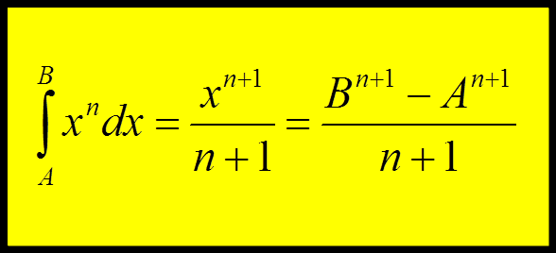

A combination of URL and hyperlink is a very useful alternative to the above. If the link fails, or the document is printed, the reader can access the website with the URL, by typing it into a web browser. An example of a combination URL and hyperlink is presented below:
www.David100.com

How Do You Create a Hyperlink, and a Combination of a Hyperlink and URL
|||
The above raises the question, how do you create a hyperlink, and a combination of a URL and hyperlink. The answer to this question depends on the software you are using. Each software package uses a somewhat different technique. For Microsoft Word, you can create a combination of a URL and hyperlink, simply by typing the URL into a Word document, and pressing the enter key, or spacebar. When this is done, the cruiser must be in the position shown below: www.David100.com| The red parallel line | represents the cruiser in this example.
To create a hyperlink with words, numbers, or a photograph in Microsoft Word, the technique is more complicated than the above. This is explained below in three steps:

Step 1) Select the words, numbers, and/or photograph that you want to use for the hyperlink. For an example let us assume the words that we are using for the hyperlink is: David Alderoty’s resume

Step 2) On the Insert menu click on the hyperlink icon, which looks like the following:

After clicking on the hyperlink icon, the following dialog box will open:

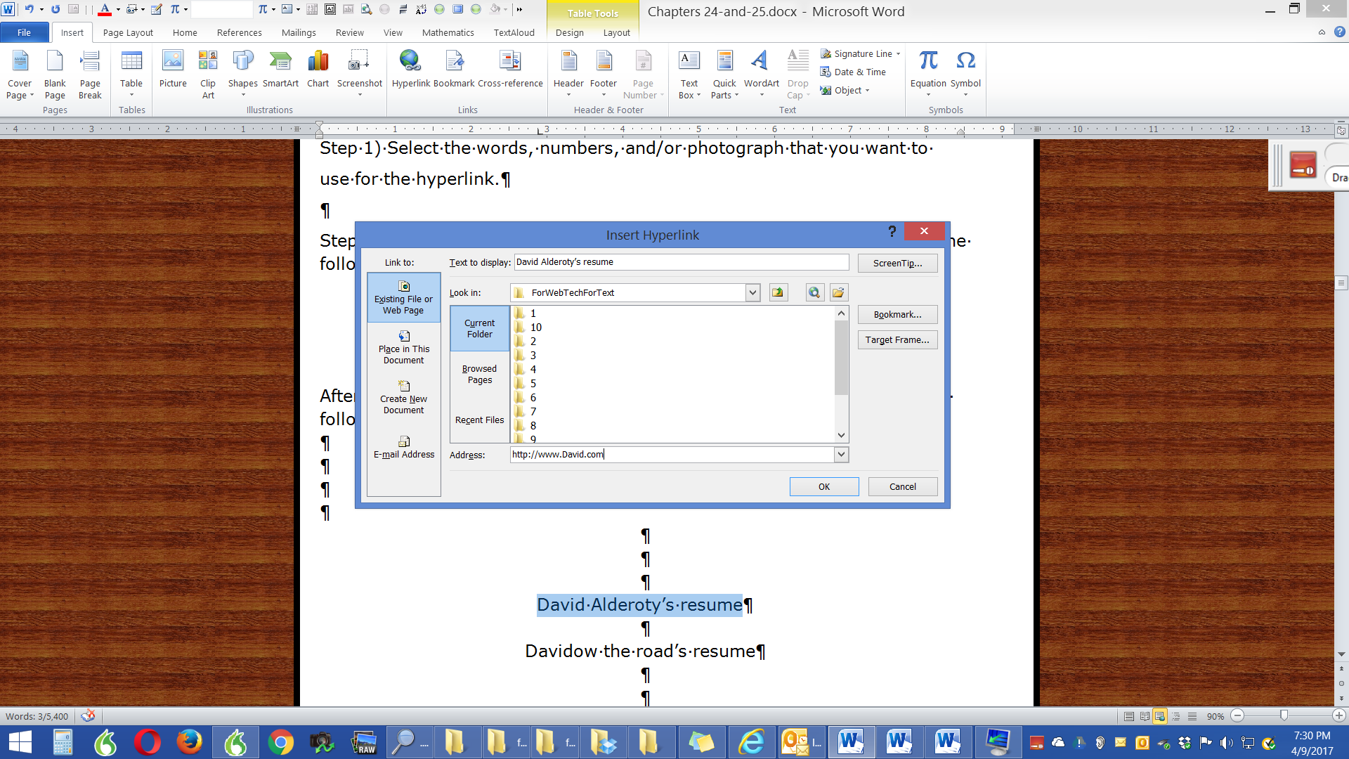

Step 3) Enter the URL in the lower portion of the dialog box, where you see the word Address, and then click OK.

This should result in a functioning hyperlink, such as the following:

David Alderoty’s resume

For Additional Details About Hyperlinks See the Following Web-Based Material
|||
YouTube search pages: How to create hyperlinks in Microsoft Word

How to create hyperlink in Microsoft Word

How to create a hyperlink in Microsoft® Word 2013

Word 2010: Hyperlinks

YouTube search pages: How to create hyperlinks

Creating hyperlinks in Microsoft Word, YouTube search page

Creating hyperlinks in WordPress, YouTube search page

When Not to Use Hyperlinks
|||
If your document is going to be printed, do not use hyperlinks. The printed material should always use URLs, such as www.TechForText.com. When the document you are writing is going to be presented in print and the electronic format, you should use URLs that are also hyperlinks, such as the following: www.TechForText.com

Avoid Long URLs, by Using a URL Shortener
|||
A URL Shortener, is web-based software that shortens URLs. There are many URL Shorteners on the web, which can be seen from the following links:
Google search pages: “URL Shorteners”, List of URL Shorteners, and TinyURL!
Long URLs should not be placed in a document, especially if it will be distributed in a printed format. If a URL is excessively long, you can shorten it, with Google URL Shortener, which is located at https://goo.gl For example, presented below this paragraph there is an excessively long URL, which was shortened with Google URL Shortener to https://goo.gl/AhxUMZ

https://www.google.com/webhp?sourceid=chrome-instant&rlz=1C1OPRA_enUS705US705&ion=1&espv=2&ie=UTF-8#q=Software+created+by+%22David+Alderoty%22&*

Topic 4.) Technique 27) Using Your Own Web-Based Material as Supporting Evidence
|||
Technique-27, involves using your own web-based material as supporting evidence. This generally requires creating one or more websites to display your work. You can use electronically and/or photographically recorded evidence that you personally placed on the web, as explained below:

- Photography can be used to support the validity of claims that involve your skills that result in physical entities, such as artwork, electronic devices, experiments, furniture, or inventions.

- You can use video with sound recordings on the web to support skills that involve acting, dancing, gymnastics, playing a musical instrument, or singing.

- There are many types of computer documents, which can be placed on the web. With appropriate content, these documents can be used for evidence of skills in graphic design, mathematics, poetry, or writing

Creating Your Own Websites, and Other Alternatives
|||
You can display your work on the web by creating your own websites, using free space, or social media websites. If you have videos to display, YouTube is an ideal choice. One of the best options is renting web space to create your own websites. This involves obtaining your own URLs. This can be done for as little as $10 a month. See the following web-based sources for additional information:
- How to create a website with Microsoft Word, YouTube search page

- How to create a website with WordPress, YouTube search page

- Google search pages: How to create your own website

- YouTube search pages: How to create your own website

- YouTube search pages: How to create a WordPress website

- Google search pages: A list of Hosting services

Topic 5.) Technique 28) This Represents Any Technique That Is Not Mentioned In This E-Book
|||
In this e-book, 27 techniques were already explained, but there are probably a number of additional techniques could be added to this list. Try to come up with some of your own techniques for supporting the validity of the statements you write. Some additional examples of techniques that can be useful supporting evidence of presented below:
- Professional knowledge, judgment or experience,

- Using examples as supporting evidence

- Using comparisons as supporting evidence

